- Application Form (General Details)
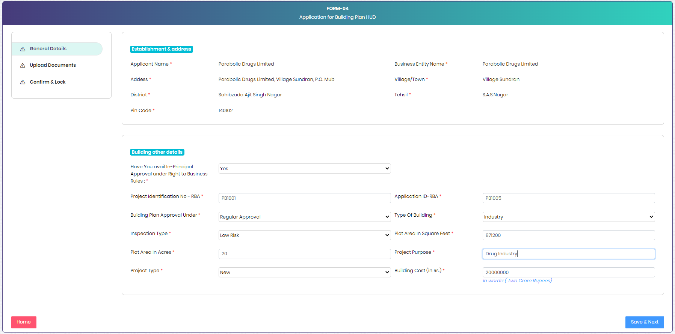

- Application Form (Document Uploads) – Part-1
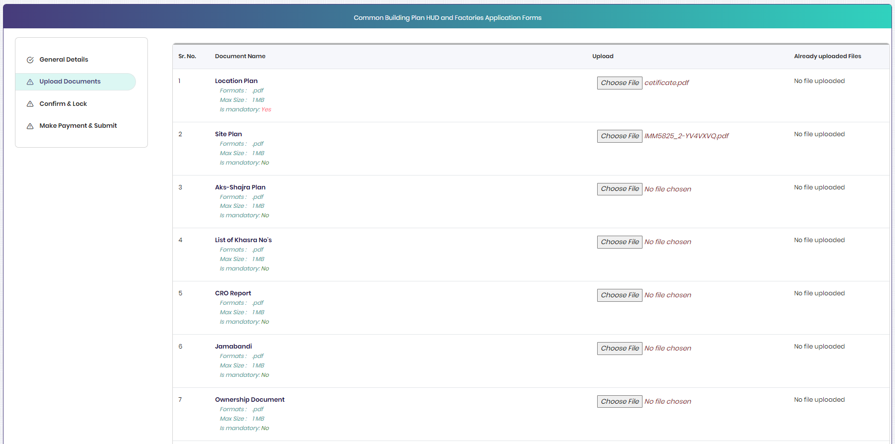

- Application Form (Document Uploads) – Part-2
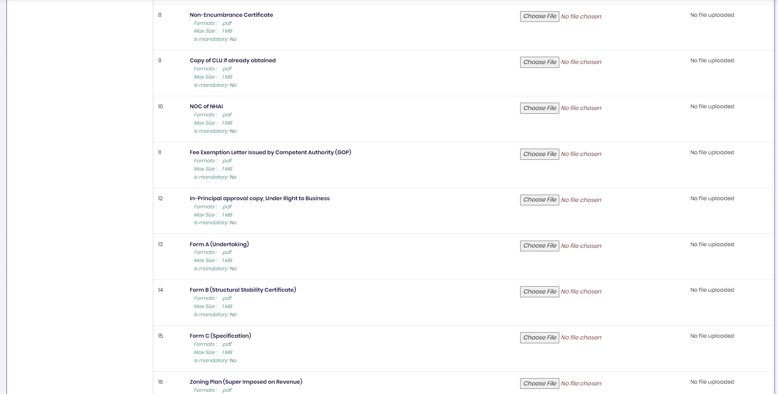

- Application Form (Document Uploads) – Part-3
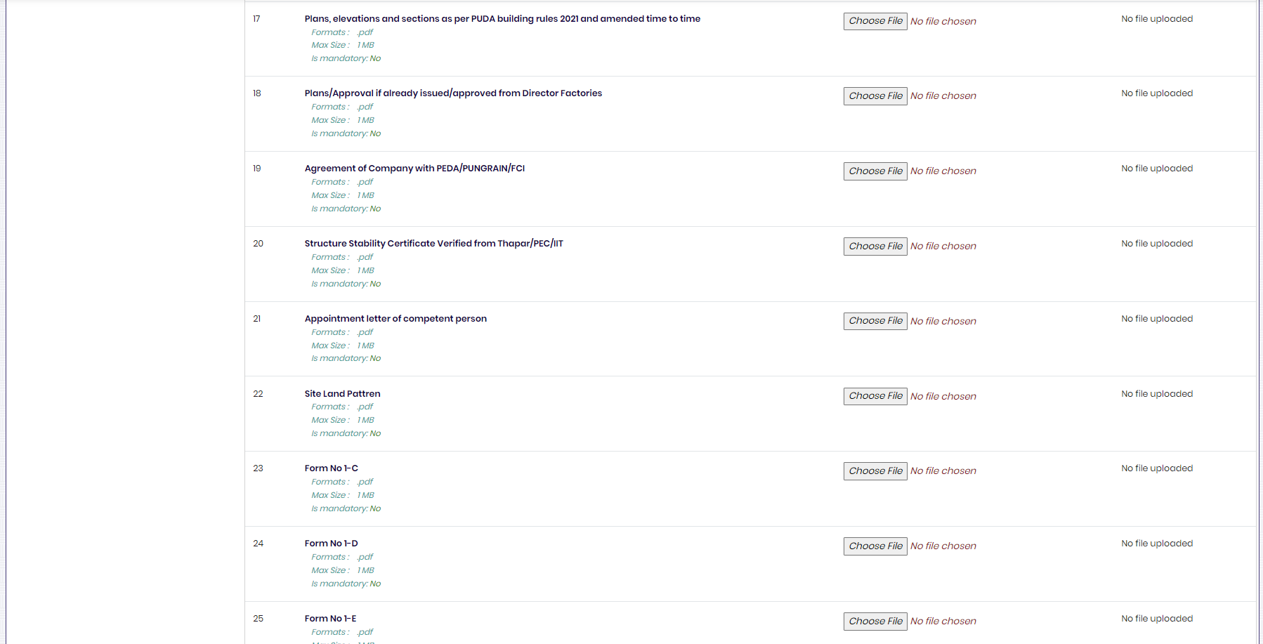

- Application Form (Document Uploads) – Part-4
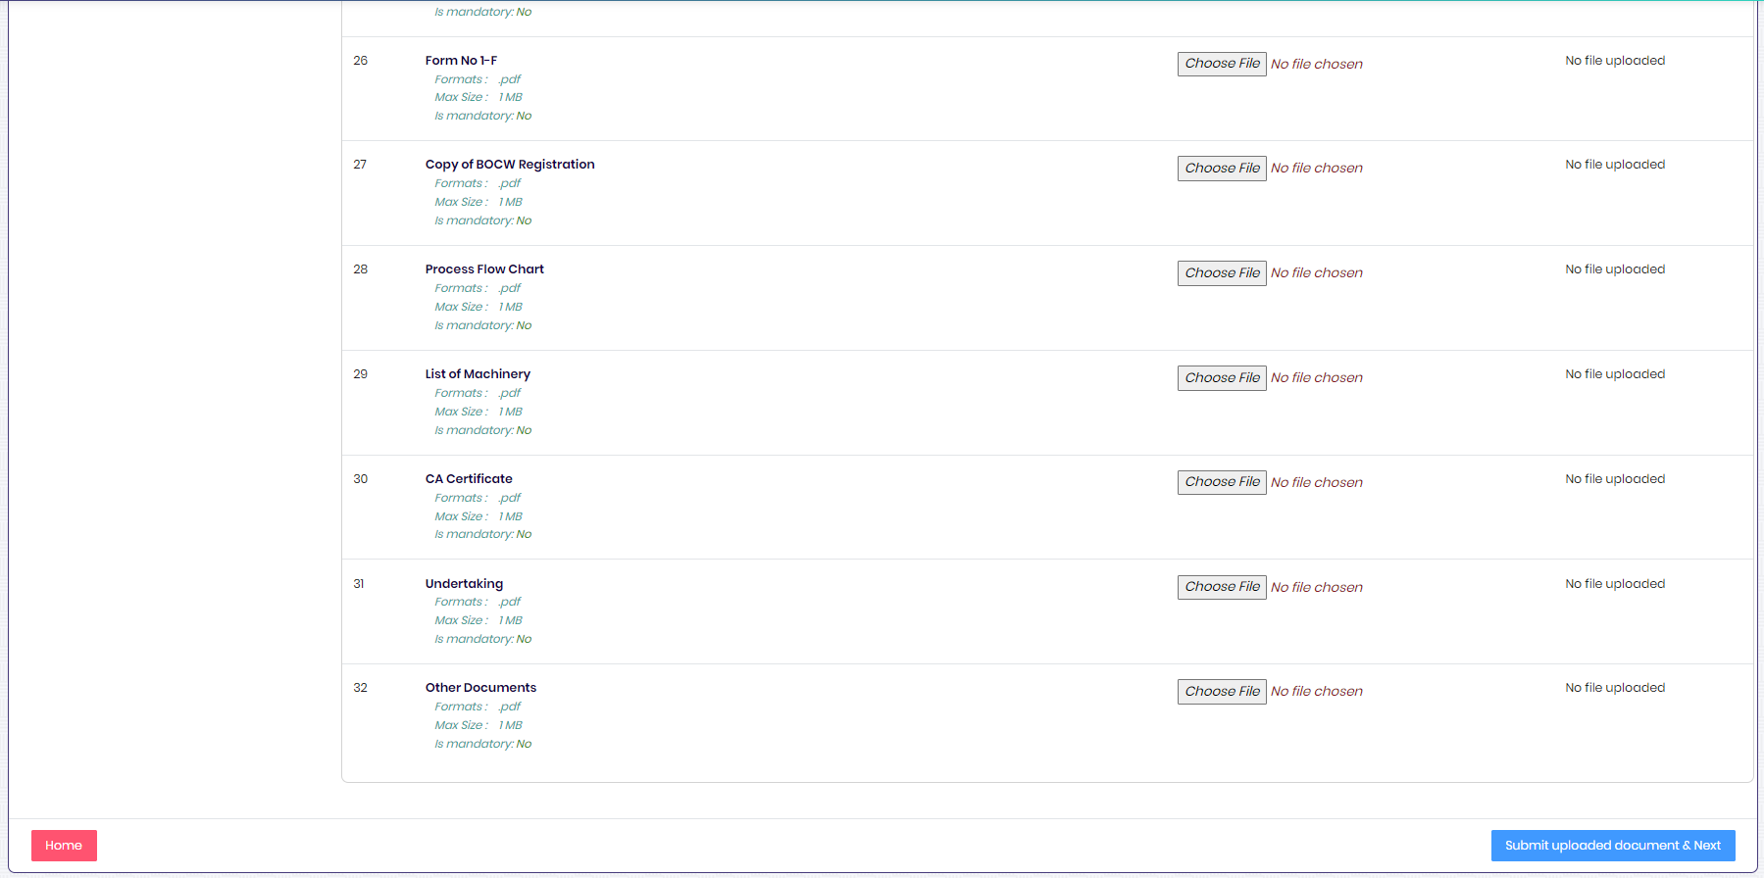

- Application Processing Fee Calculator
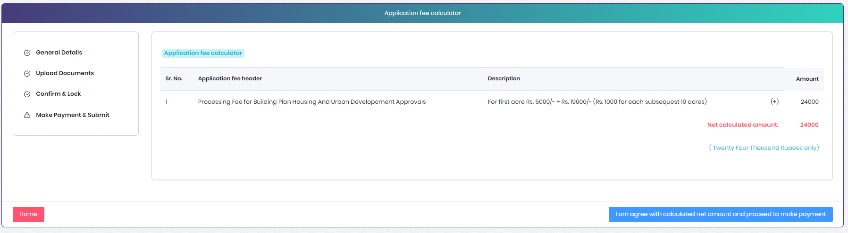

- Officer Dashboard (After make payment by applicant and officer can take action on files received)

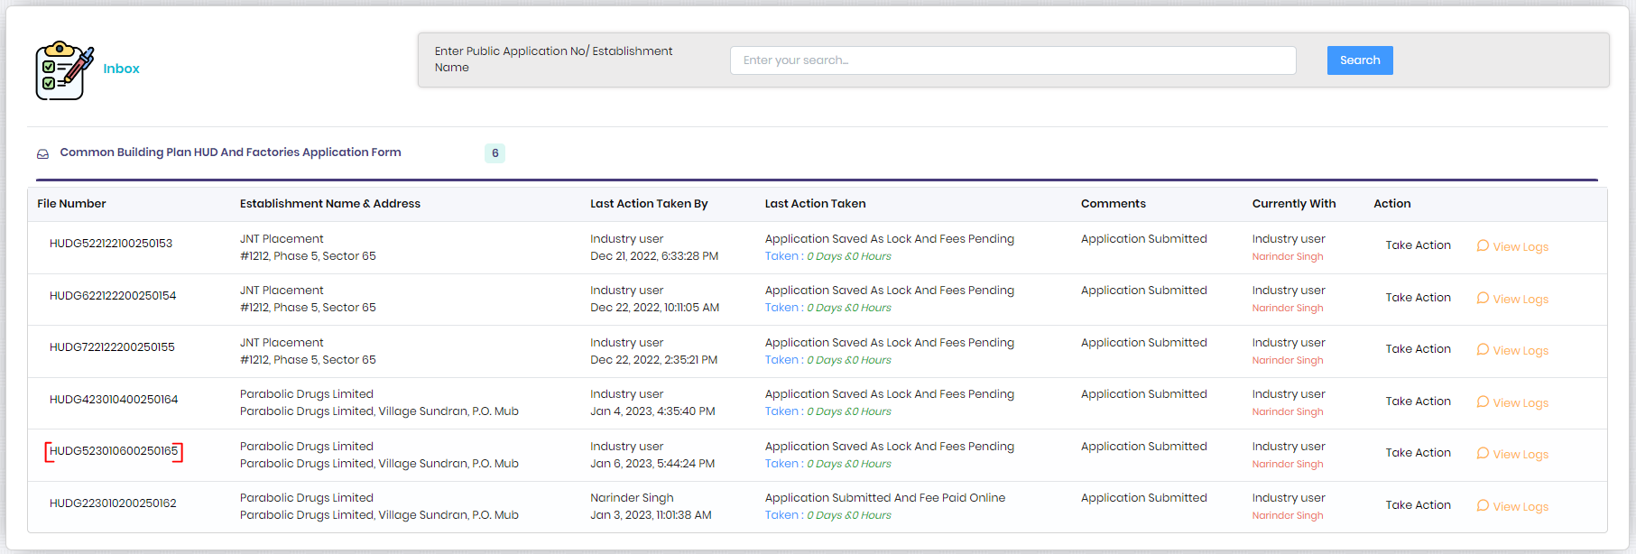

- Officer take action window (Using multiple tabs on left hand side, officer can view Noting logs, Application Form, Attachments and Payment Details)
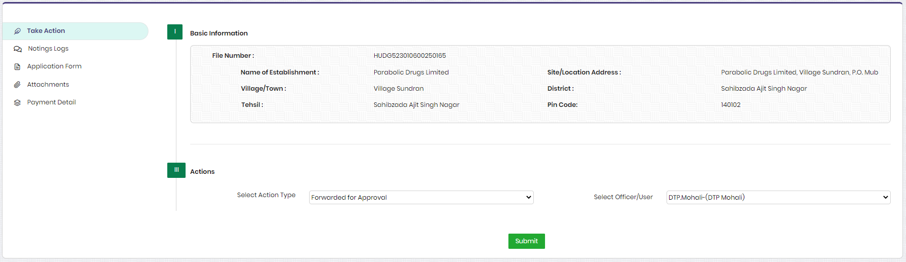

- Raise Fee Window (By JDRF)
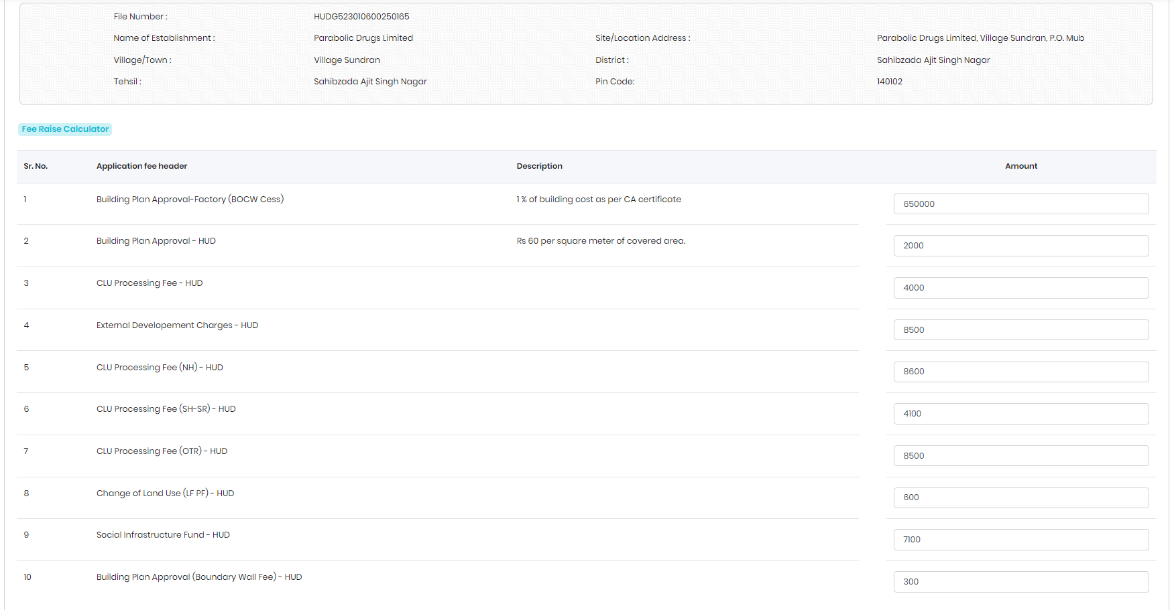

- Make Payment By Investor (Fee raised by Officer)
